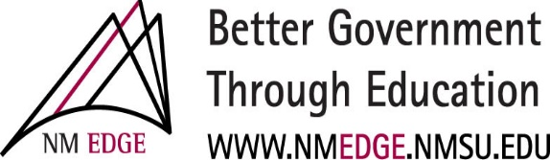

2025 Advanced Public Purchasing Online Classes

NM EDGE ADVANCED Public Purchasing Classes, November 17-21, 2025
Live Online via Zoom

The CPO Foundation classes, and tests are prerequisites to any of the Advanced Public Purchasing classes.

MON. Nov 17
8:30 -11:30 am NMP 201: Solicitation & Process of Bids
1:00 – 4:00 pm NMP 203: Negotiation Strategies

TUES. Nov 18
8:30 -11:30 am NMP 202A: Request for Proposals (coreq)
1:00 -4:00 pm NMP 202B: Request for Proposals

WED. Nov 19
8:30 -11:30 am NMP 204: Roles & Resp for NM Construction
1:00 – 4:00 pm NMP 206: Adv Const & NM Law (PRQ NMP 204)

THURS. Nov 20
8:30 -11:30 am NMP 205: Advanced Contract Admin
1:00 – 4:00 pm NMP 207: Protest Process in NM

FRI. Nov 21
8:30 -11:30 am NMP 208: Advanced Purchasing Admin (elective)
1:00 – 4:00 pm NMP 209: Adv RFP (PRQ NMP 202A & B) (elective)

For more information: NMEDGE.NMSU.EDU or Contact us at: nmedge@nmsu.edu

